**IMAGES OF RUN RESULTS:**

Chrome browser launched successfully

Filtered out for Books only and “the Lost World by Arthur Conan Doyle” book is searched.

The total count of result for the searched book

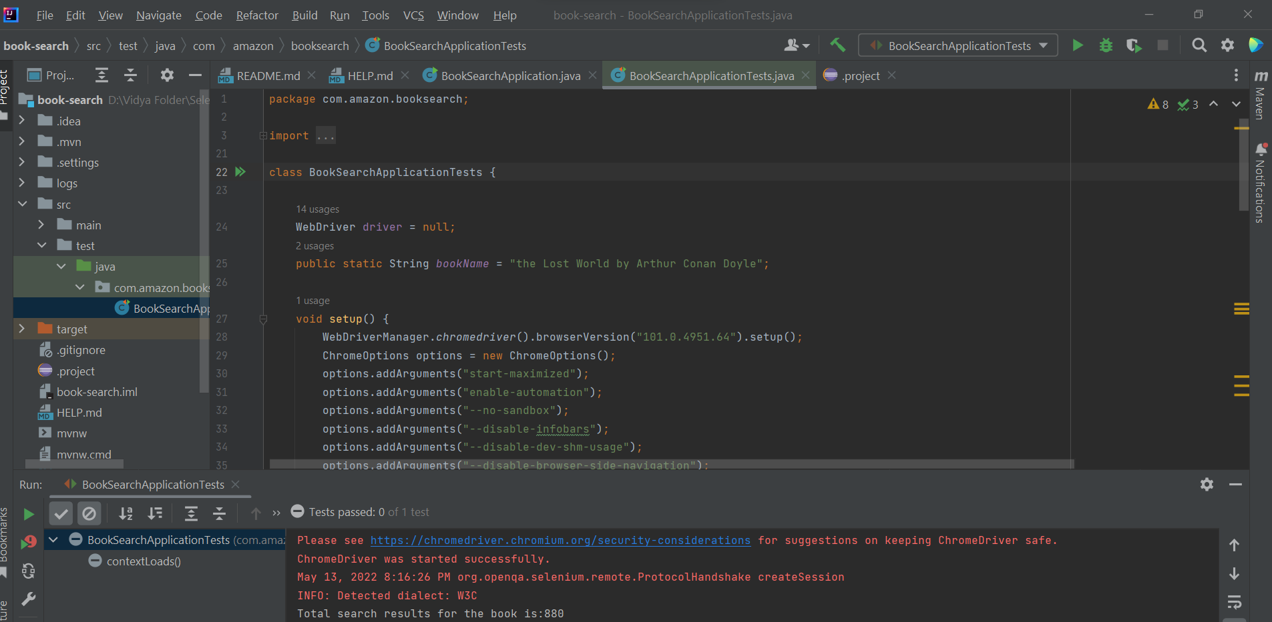



Book count after the filter “Book Language-English”

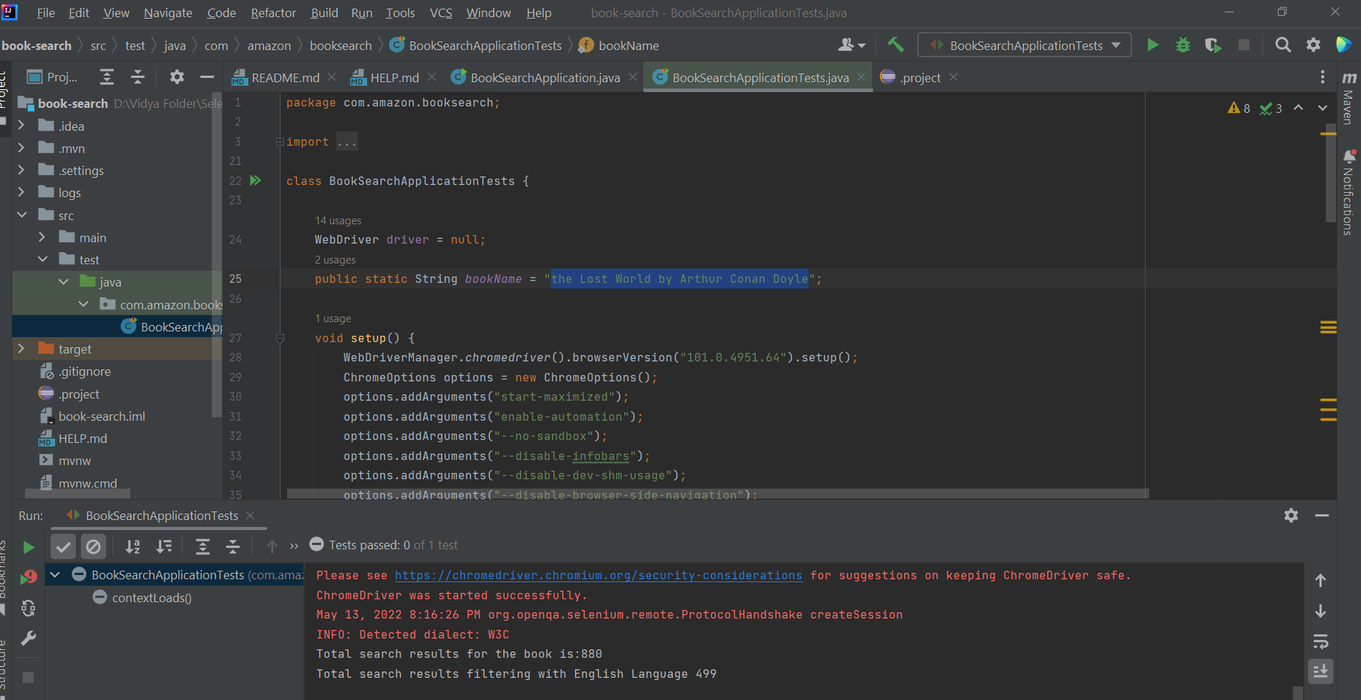



After Navigating through all the pages, retrieving the max characters of Book name which is not longer than 70 days.

